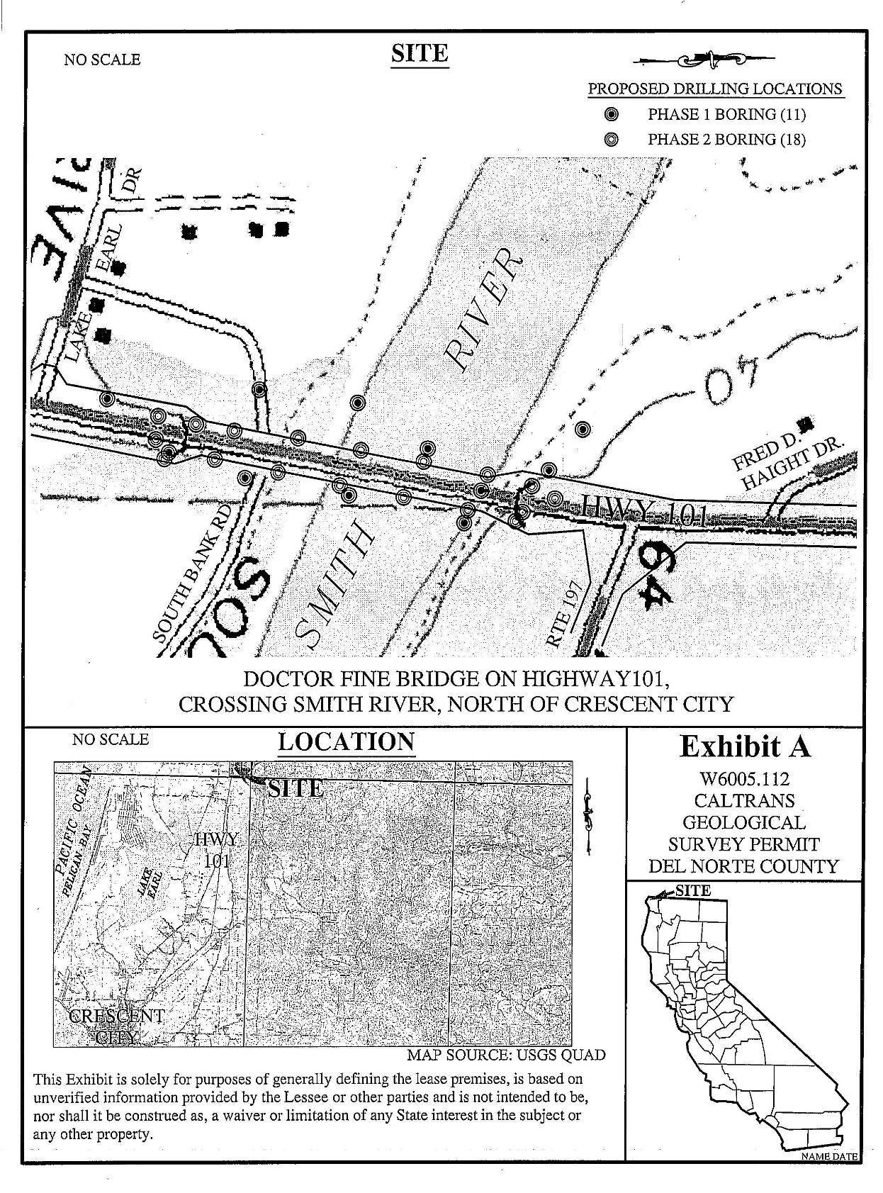
W 6005.112
EXHIBIT A

